Question 1:

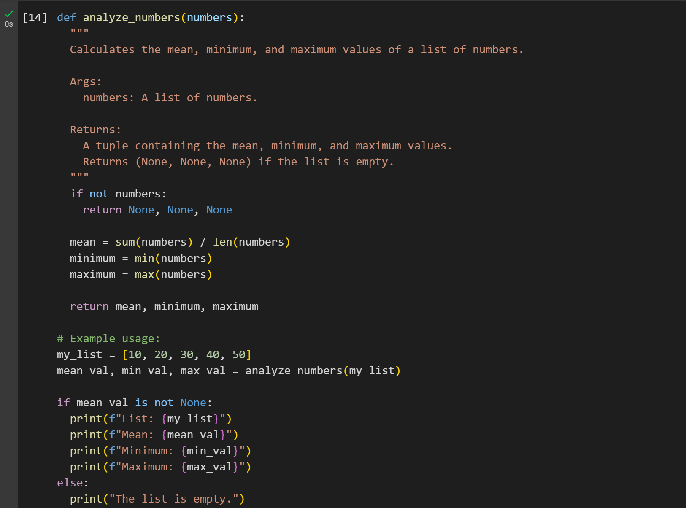

Output:

Question 2:

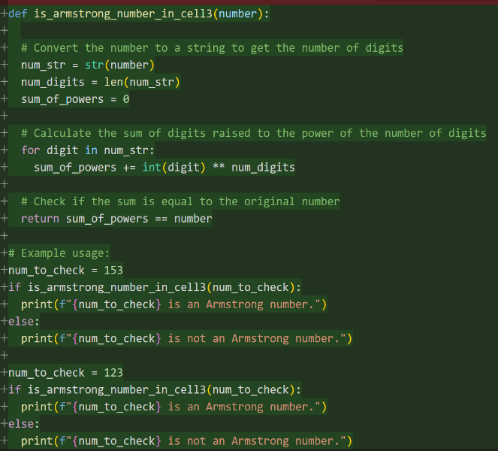Gemini: Copilot:

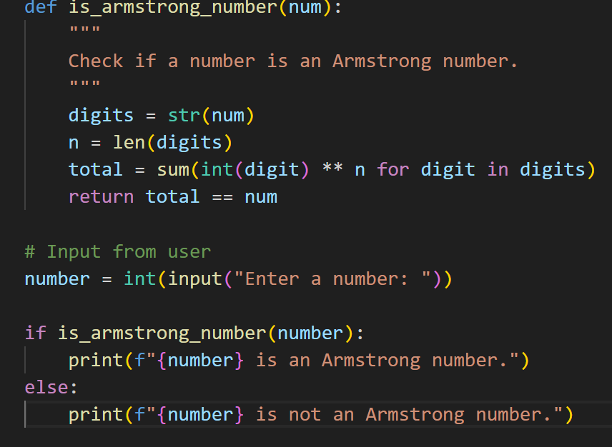

Output:

Question 3:

Question 3.2:

Question 5:

Output:

Student written code:

Output:

Question 4:

Output:

